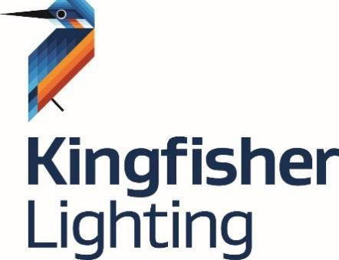

Returns Policy - Kingfisher Lighting

Returns Policy
- You, the customer will request the return of goods supplied within 30 days of receipt of delivery.
- A request to returns goods form must be complete with the following information, to notify Kingfisher of;
  - The quantity of goods to be returned;
  - The delivery note no. and the Kingfisher order number to which the goods relate;
  - The reason why the goods need to be returned.
- Goods will only be accepted for return if agreed by Kingfisher, either in writing or by email.
- If the goods are no longer required by you and were not specifically manufactured for you a handling charge of 20% of their original value will be made to Kingfisher by the customer. If the goods were of special manufacture, then Kingfisher reserve the right to make a handling charge of up to 100% of their value.
- Kingfisher will investigate the request to return goods and, if acceptable, will post or email to you, the customer, an authorisation to return note including a return note no.
- Once the return of goods has been agreed by Kingfisher, the customer has 14 days to return the goods. Kingfisher reserves the right to refuse items past this timeframe.
- The authorisation to return note should be returned with the goods by the customer. Failure to provide that note on the outside of the packaging will result in Kingfisher rejecting the delivery.
- Please note Kingfisher staff are instructed not to accept any goods without sight of an authorisation to return note.
- Kingfisher reserves the right to reject goods not returned in their original undamaged packaging.
- Goods and packaging must be in pristine condition. If not, then we reserve the right to make a further deduction from any refund notified.
- The returned goods will be held in quarantine until they can be inspected. The length of time in quarantine shall not exceed five working days.
- The cost of returning the goods to Kingfisher must be borne by the customer.
- Kingfisher Lighting are unable to offer a free collection service for customers wishing to return items.
- Genuinely faulty goods will, of course, be replaced free of charge, but we reserve the right to charge for replacement items or services supplied, when the fault lies with other parties.

- Sale or return samples are supplied on the basis that an invoice for the full value of the goods will be issued if the sample has not been returned within 3 months of the original delivery date.
Note:
By completing and returning the ‘Request to Return’ form, you are agreeing to have read and accepted
the terms of this Returns Policy.




Request To Return Goods

Customer: Date:

We wish to return the following goods listed below:

Qty | Part No | Kingfisher & customer Order No. | Kingfisher Invoice No. | Debit Note No.

Please tick appropriate box
The reason we wish to return these goods is that:
- The items are no longer required by us 
[ ]
- The items were found damaged on receipt 
[ ]
- The items were found faulty upon receipt
[ ]

- The items were incorrectly supplied
- The items were incorrectly ordered
[ ]
[ ]

Please give further details

Signed by: On behalf of:

Please complete and return this form to: Kingﬁsher Lighting
Kingfisher House Crown Farm Way
Crown Farm Industrial Park, Nottinghamshire, NG19 0FT Tel: 01623 415900

On receipt of this form an Authorisation to Return Form will be issued

V5 01.08.2025

