ENVIRONMENTAL POLICY STATEMENT

Kingfisher Lighting is a leading designer, supplier and installer of exterior lighting products and fixings including the design of lighting schemes and the manufacture, assembly, supply, distribution, management of installation and maintenance of lighting and associated equipment. As such we as a company are committed to a policy, in all its operations and on a continuous basis of minimising its impact on the environment, protecting the environment, preventing pollution, and adhering to all environmental legislation. The policy is available to all interested parties as is appropriate.

To this end the company will understand the context of the organisation by reviewing internal and external issues regularly which impact the Company and aspire to maintain an environmental system in accordance with the requirements of the latest version of BS EN ISO 14001. The Company will take measures to incorporate environmental management methods into working practices across all areas of the business, while considering the needs and expectations of all interested parties.

Senior Management is totally committed to environmental protection, throughout the organization and will ensure that adequate resources are available for its achievement. All employees are made aware of the Company's Environmental Policy and their involvement in the system during induction and ongoing training as appropriate and the commitment made therein. All Directors and Managers are totally committed and contribute to the implementation, execution, and control of local environmental issues.

The company shall regularly review the environmental aspects and pollution prevention controls pertaining to its operations and shall endeavour to ensure that these are carried out in such a manner as to make the most efficient use of energy, materials and natural resources; to prevent or minimise any adverse impact on the environment; and to comply with relevant statutory regulations. This applies to the design of processes, buildings, and equipment as well as our products and other operational activities across the company.

To enable improvement in environmental performance, objectives, and targets for improvement shall be set in line with this policy and environmental risks which shall be reviewed on a regular basis. The Company shall proactively encourage its supply chain to adopt sound sustainable and environmental practices.

Signed:

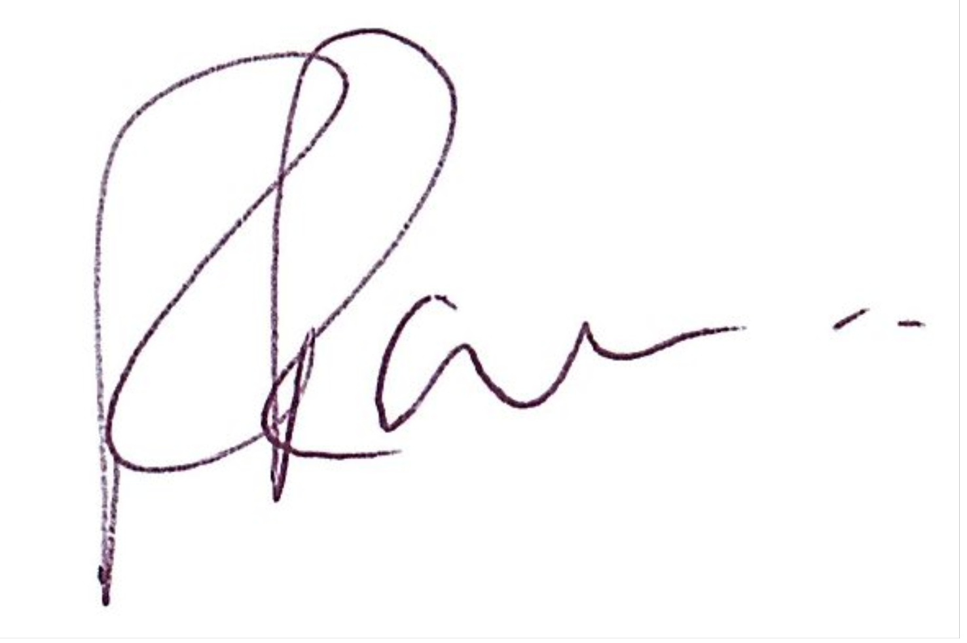
Roger Rawson
Managing Director
08/04/2025

